Attached are the instructions on how to fill out your SAR and CAR. These are based on your Certify Teacher Exam mode (last attempt). The SAR is only for Domains where you scored below 80%. You will list the domain and competency where you scored below an 80%. This will help you identify the areas you need to focus.
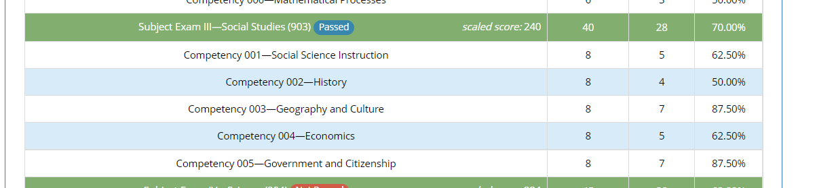
For the CAR, Go to your last exam on Certify Teacher. Scroll down to the bottom of the page.
Click on then again scroll down to the bottom of the page and click on
The following will appear:
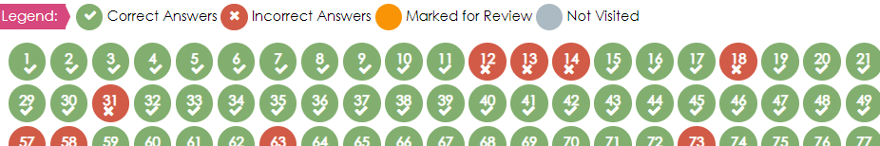
The green are correct answers and the RED ARE INCORRECT answers. Click on the red circle (one at a time) and the question followed by an explanation appears. Read the Introductory Commentary.
For the CAR you will need to write the SKILL TESTED and you must identify the correct response, review the correct answer and briefly explain an understanding of why that is the correct answer.
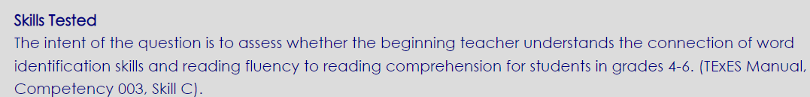
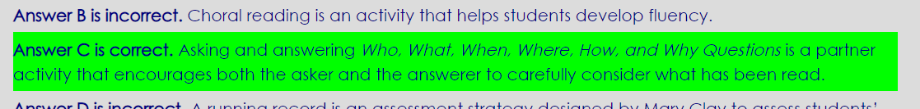
The templates are ready for you to add your information. Just continue the write up until you finish.

SAR (Self-analysis Report) HOW MANY CORRECT ANSWERS YOU GOT IN COMPARISON TO HAW MANY QUESTIONS PER COMPETENCY.
CAR (Corrective Analysis Review) WHY IS THIS THE CORRECT ANSWER.
Self-Analysis Report (SAR) Template (RED IS A SAMPLE…PLEASE DELETE AS YOU WORK ON YOUR PLAN)
SUBJECT EXAM | Domain | Competency | Self-Analysis (below 80%)
 | Domain (SUBJECT 2 -Math) | C# 001 Math Instruction | I SCORED 5 OUT OF 9 CORRECT  I NEED TO STUDY FOCUS MORE ON THIS AREA
EC-6 | Domain (SUBJECT 2 -Math) | C# 006 – Mathematical processes | I SCORED JUST 3 OUT 7  I NEED TO REVIEW THIS AREA

CORRECT ANSWER REVIEW (CAR) Template - (Red Text is a Sample – You may Delete as you work on plan)
INCORRECT QUESTION#/Competency#/Skill Tested | CORRECT ANSWER REVIEW (Read Commentary)
Q12/C003/- The intent of the question is to assess whether the beginning teacher understands the connection of word identification skills and reading fluency to reading comprehension for students in grades 4-6. | Upon a review of the correct answer, the answer I chose was D, however I can see the Asking and answering Who, What, When, Where, How, and Why Questions is a partner activity that encourages both the asker and the answerer to carefully consider what has been read.
(EXAMPLE) Q5/C6/Skill E | (Your corrective review)

